25th November 2019

**YOKOHAMA returns to DAKAR with its GEOLANDAR M / T G003**

YOKOHAMA joins the most demanding rally-raid challenge in the world once again, with the help of the SsangYong Spain team and its new Korando DKR vehicle. The Óscar Fuertes-Diego Vallejo partnership, which achieved success in 2018 with a second place among the debutants, fourth in T1.3 category and 30th overall and a meritorious third place in category T1.3 and 33º overall in 2019, returns with a new specialised vehicle to meet the new challenges, this time in Saudi Arabia in early 2020.

The team will once again fit the spectacular “GEOLANDAR M / T G003” tyre, which has had a magnificent performance in the previous editions.

From January 5 to 17, the DAKAR will be held in the Middle East, with a heavily demanding route that sets off from Jeddah and concludes in the new mega-centre Al-Qiddiya, just 40 kilometers from the capital Riyadh, where the rest day will take place. The planned route is divided into 12 stages with a total of over 12,000 kilometres including timed stages. The Dakar will go through a wide range of landscapes with diverse challenges.

According to the car manufacturer, with respect to its predecessor - the Rexton DKR of 2019, the new Korando DKR is wider, taller and longer: it measures 4,800 mm long (+100), 2,300 mm wide (+100) and 2,050 mm (+100 ) High. The wheelbase increases from 2,900 to 3,100 mm, although the width of the front and rear tracks remains unchanged (1,880 mm). In race configuration, the SsangYong Korando DKR is around two tons in weight, but is capable of reaching a top speed of 195 km/hr. It also has a new multitubular chassis that significantly reduces the center of gravity, increases stiffness and reduces weight; In addition to other modifications that have enhanced the vehicle.

Meanwhile the YOKOHAMA “GEOLANDAR M / T G003” is an off-road of the GEOLANDAR range for SUVs and Pick Ups. It provides extreme performance in off-road scenarios, from mud to rock, earth and gravel. The tread of the “GEOLANDAR M / T G003” includes a large mesh of blocks and sequential lamellae that help the achieve excellent traction on various off-road surfaces. In addition, the “GEOLANDAR M / T G003” has a thickened side with an aggressive block at the top of the side of the tyre. This block increases resistance to cuts and wear.

In the last edition, driver Óscar Fuertes declared: “The YOKOHAMA GEOLANDAR have driven more than 80% of the time at really low pressures, and have not suffered any deformation. Perhaps the most incredible thing is that in more than 3,000KM of sand, stones, mud and track, we have not suffered a single puncture. ” We are sure that in the 2020 challenge the performance of these tyres will be equally successful.

“GEOLANDAR” is the global brand of YOKOHAMA for SUVs and Pick Ups. Given the global growth in the demand for SUVs and Pick Ups in recent years, YOKOHAMA has accelerated its development and the introduction of new additions to the “GEOLANDAR” range.

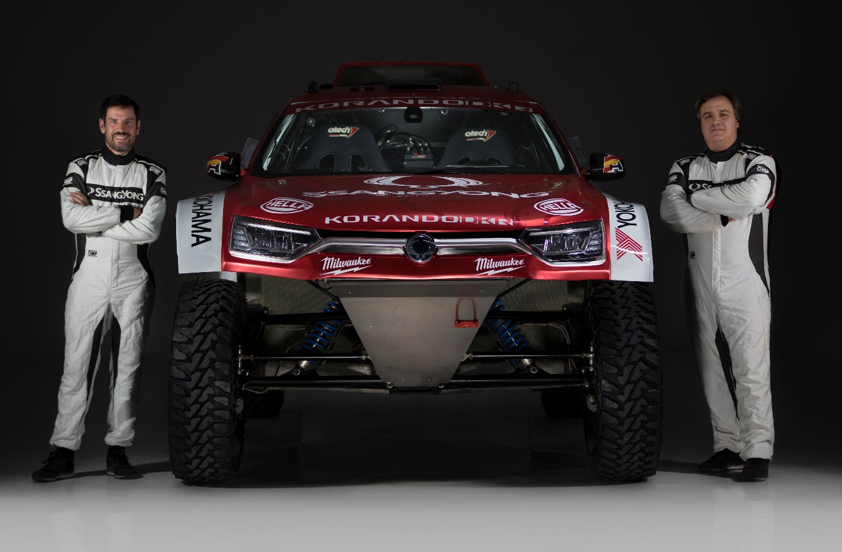

*The new Korando DKR with Yokohama Geolandar G003 tyres L to R Diego Vallejo & Oscar Fuertes*

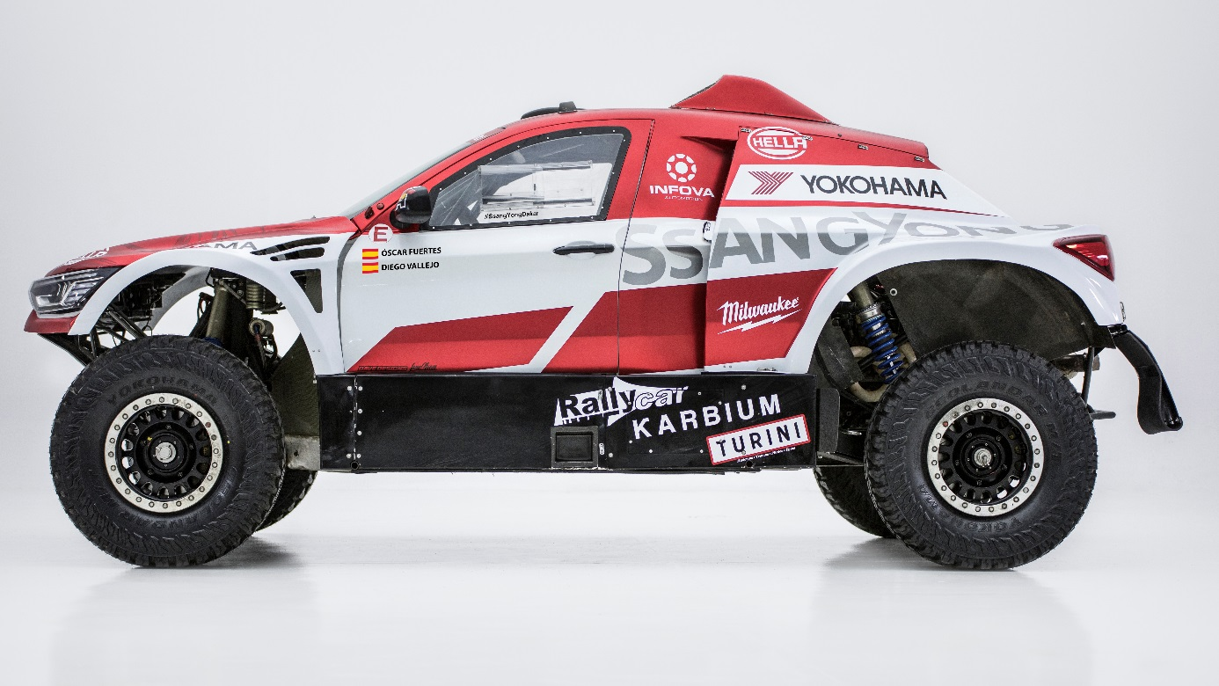

*SsangYong Korando car for the Dakar 2020 fitted with YOKOHAMA Geolandar MT G003*